Chichester City Riders

Open 10 Mile Time Trial

Sunday 6August 2023 at 0730hrs

On the Fontwell P901/10 course

**Time keepers:** Peter Delve and Neil Panter

**Sign on :** Phil Webber & Lily Wiltshire

**Headquarter:** Aldingbourne Community Sports Centre, Olivers Meadow, Westergate, Chichester PO20 3YA

Opens 0630

**Important notes**

* Please respect residents, noise levels around the HQ early in the morning, parking respectfully as well as any warm-up you conduct
* SIGNING-ON SHEET & RACE NUMBERS - Riders must sign the Official Signing-On Sheet at the Event HQ to obtain their Race Number.
* Position your number so it is visible from the rear, if using racing pockets please use the left side to help timekeepers
* Please return your number to the HQ when you sign out. Failure to sign out and return your number will be recorded as DNF
* Head up! Please look where you are going at all times.

IN THE INTERESTS OF YOUR OWN SAFETY, Cycling Time Trials and the event promoters require you to wear a HARD-SHELL HELMET that meets an internationally accepted safety standard. It is also compulsory that a WORKING FRONT & REAR LIGHT, either flashing or constant, is fitted to the machine in a position visible to following road users and is active while the machine is in use

**Course description P901/10**

**START** in Lay-by on A27 on westbound carriageway of A27 at North end of Fontwell Race Course at Drain Cover approximately 20 yards west of Lamp Post 181/08 ( SU947072).

PROCEED west along A27 to Tangmere RAB where straight across to continue on A27. Take 1st slip road up over Tangmere Flyover signposted to the A285 to South RAB and Turn RIGHT 2nd Exit to cross the flyover to North RAB. Take **1st Exit (straight across)** and north onto the A285 for 800 Yards to Temple Bar and Turn LEFT on to an Roman road, Continue on this road through the village of Maudlin and at the Mini roundabout continue straight on **2nd Exit** onto Stane Street to Westhampnett RAB (5.1 Miles) (SU827060). See Images on next page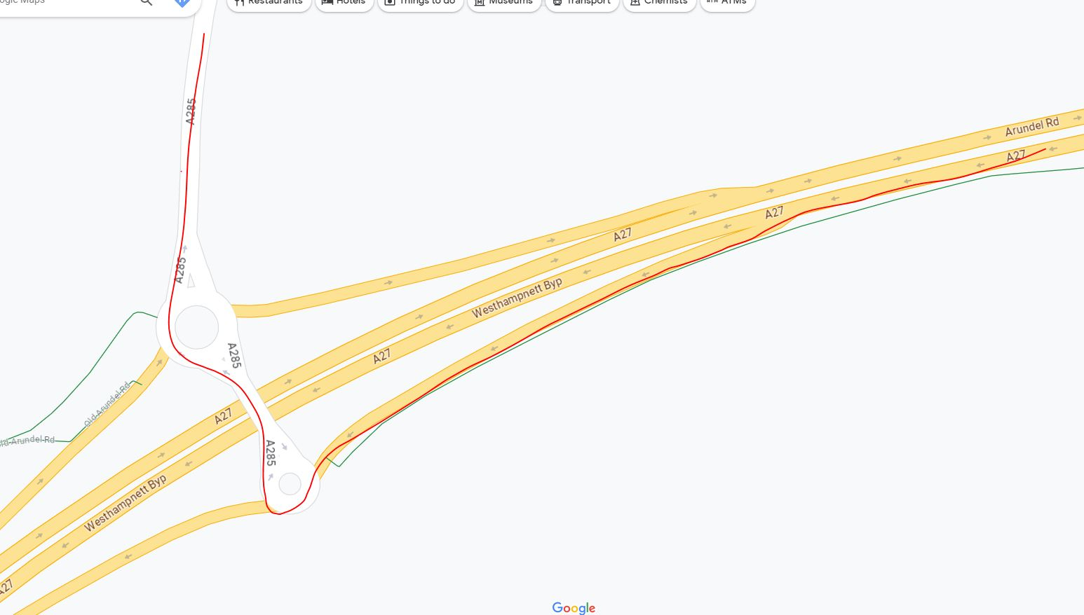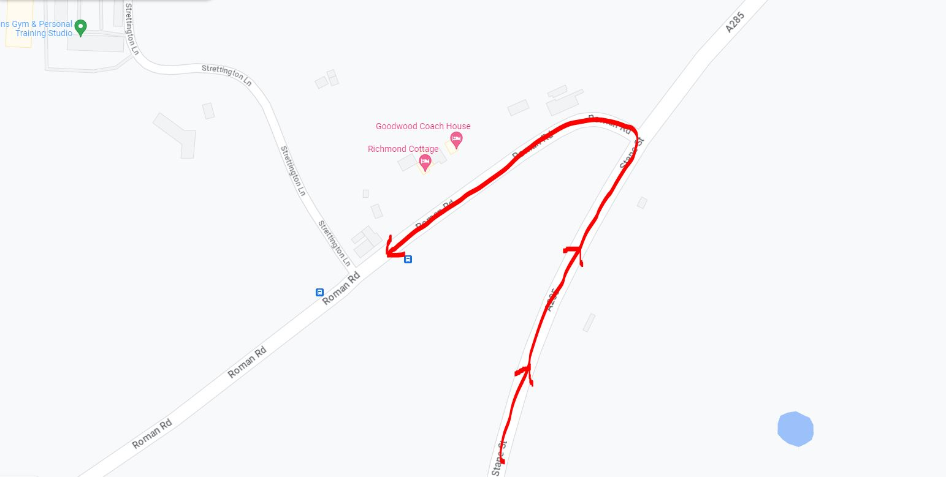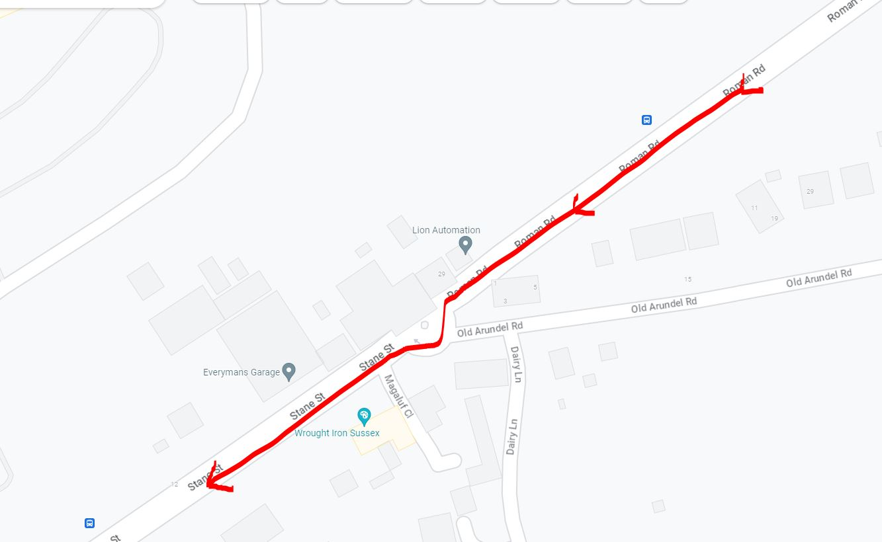

At Westhampnett RAB **TAKE 1st** Exit on to old A27 to Portfield RAB (5.4 Miles) where take **1st Exit** on to A27 Westhampnett By-pass and proceed under Tangmere Flyover to Tangmere RAB where **2nd exit** (straight across) to continue on A27 to

**FINISH** 20 yards beyond entrance to a house called “Westergates” and approximately 150 yards short of the START (10 Miles) (SU946072)

Course: <https://www.cyclingtimetrials.org.uk/course-details/p901-10>

**SAFETY INSTRUCTIONS**

Riders must:

* not cross the A27 in the Start and Finish areas.
* use the recommended safe routes to the Start and to return to the Headquarters.
* not warm up on the Course.
* exercise care at the following locations
* crossing Tangmere RAB both ways
* turning LEFT at Temple Bar. Caution 150-degree change of direction.
* passing exit and acceleration lanes at Tangmere Flyover.
* negotiating all roundabouts.
* passing all acceleration lanes from “B” and unclassified roads joining the A27.
* not turn RIGHT at Fontwell West RAB after the FINISH but should continue on A27 to turn LEFT into Duke’s Road to return to the Event Headquarters

**Any rider observed riding in a manner which may jeopardise his or her own safety, the safety of others and the future of the Sport will be disqualified and reported to the South District Council of Cycling Time Trials.**

**Any rider turning RIGHT at Fontwell West RAB to leave the A27 will be disqualified.**

**EVENT HEADQUARTERS**

Aldingbourne Community Sports Centre, Olivers Meadow, Westergate, Chichester PO20 3YA.

The HQ will open from 0600hrs please do not arrive before. Plenty of parking at the venue, if you must park off site please do so respectfully. No cleats to be worn in the hall, thank you.

Refereshments on the day available from Mike Cooper in his Van.

HQ location: <https://goo.gl/maps/34KxM5eKRu7X2Af7A>

**SAFE ROUTE TO START**

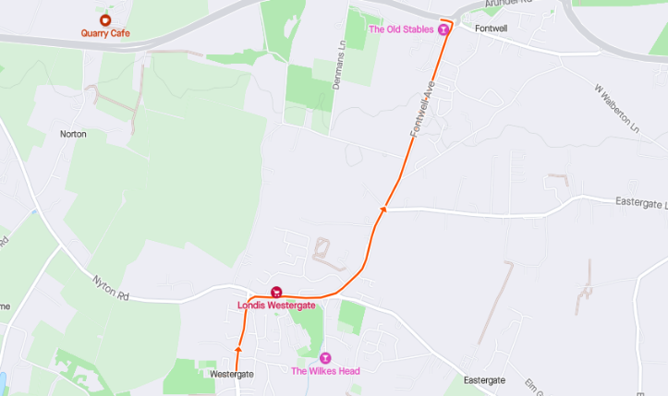From the HQ, Olivers Meadow, turn left onto Westergate Street. Follow the road to the right into Nyton Road at the RAB turn left onto Fontwell Avenue. Follow the road to the Fontwell West RAB, turning left to the start (Arundel Road) A27.

Approximately 1.7 miles and 7-minute ride

Please do not enter the start lay-by before 5 minutes to your start time, thank you.

**SAFE ROUTE FROM FINISH**

After the finish line take the left turn at the Fonwell West RAB A27. Continue on A27 to Dukes Road (first left) after 50yrds taking the left turn onto the shared cycle path (please take this section carefully due to surface changes and tight corners) Continue through the underpass, turning right on London Road. At the RAB turn right onto Arundel Road to the RAB. Turn left onto Fontwell Avenue (A29). Follow the road to the RAB, straight over onto Nyton Road, following the road around to the left into Westergate Street, taking the fourth right turn into Olivers Meadow and to the HQ.



Approximately 2.3 miles and 8-minute ride

Any rider turning RIGHT at Fontwell West RAB to leave the A27 will be disqualified.

**Results:** www.resultsheet.app

**Prizes:**

1st, 2nd 3rd Overall, 1st Woman and 1st Road bike

Spot prizes on the day, explained upon sign up at the HQ!

Make sure you stay on after your ride, you could always be a winner!?!

**Event secretary** Larry Wiltshire 07889170893

**Event manger and contact on the day** Phil Webber – Race HQ - 0781104533

Thank you for supporting our first Open event, please speak to a members of the club regarding any feedback you have. A big thank you to our sponsor for making this happen Harkman Technologies and of course our time keepers and volunteers for giving their time. We look forward to seeing you at our next event……!

Thats not all – Post TT coffee ride?! We will be taking a leisure 20ish mile ride taking in a coffee stop to run through the tales of the TT efforts – all are welcome so please hang on after to join the fun, TT bike friendly